Electricity & Magnetism

Remember to photocopy 4 pages onto one sheet by going A3→A4 AND back to back on the photocopier

Student name: ________________________________

This booklet contains every higher and ordinary level question that has appeared on an exam paper on this topic from 2002–2023
Worked solutions to Ordinary Level Maths questions can be found at the end of the booklet.
Fully worked solutions to all higher level past papers can be found on the homepage of thephysicsteacher.ie

Screencasts of all topics plus a wide range of other resources via this link

You can find this document plus all other booklets on the homepage of thephysicsteacher.ie
Last updated: 04/08/2024
Noel Cunningham
Contents
1: Magnets and magnetic fields 3
Demonstration of a magnetic field due to a current in a long straight wire 3
Demonstration of a magnetic field due to a current in a loop 4
Demonstration of a magnetic field due to a current in a solenoid 4
Determining the direction of a magnetic field due to a current in a straight wire 5
Determining the direction of a magnetic field due to a current in a solenoid 5
To demonstrate the magnetic effect of an electric current: the electromagnet 5
Extra reading 7
SLOP 9
2: Current in a magnetic field 10
A current-carrying conductor in a magnetic field experiences a force 10
Size of the force experienced by a current-carrying conductor in a magnetic field: F = BIL 11
Direction of the force on a current-carrying conductor in a magnetic field 12
Force on a moving charge in a magnetic field, moving at velocity v 12
Derivation of F = Bqv 12
Force on a charge moving in a circular path due to a magnetic field 13
The magnetic force between two current-carrying conductors 14
Definition of the ampere 14
To demonstrate the principle on which the (old) definition of the ampere was based 14
SLOP 15
3: Electromagnetic induction 16
Demonstrating electromagnetic induction 16
Magnetic flux 17
Now we are in a position to calculate the induced emf 18
Calculating the induced emf - straightforward questions 19
Calculating the induced emf - slightly trickier questions 20
Lenz’s law 21
Demonstrating Lenz’s law 21
Electric generators 22
The microphone 22
Alternating current (a.c.) 23
Comparing alternating voltage and current to direct voltage and current 23
Mutual induction 24
Mutual induction and the transformer 24
To demonstrate the action of a transformer 25
The relationship between v_{out} and v_{in} for a transformer 26
Self-induction 27
To demonstrate self-induction (Back emf) 27
SLOP 28
Naming of Parts 30
EXAM QUESTIONS 2002 – 2022 31
Magnets and magnetism: Ordinary level questions 31
Current in a magnetic field: Ordinary level questions 32
Current in a magnetic field: Higher level questions 35
Electromagnetic induction: Ordinary level questions 36
Electromagnetic induction and Faraday’s law: Higher level questions 38
Lenz law demonstrations 40
Self-induction 42
Transformers: ordinary level questions 44
Transformers: higher level questions 45

“Nobody knows how a magnet can move a piece of metal without touching it . . .more astonishing still, nobody seems to care.”
Bruno Maddux

1: Magnets and magnetic fields

Something to think about
- Given three identical iron bars, two of which are magnetic, how would you identify the non-magnetic bar (no other equipment allowed)?

- Given two identical iron bars, one of which is magnetic, how would you identify the non-magnetic bar (no other equipment allowed)?

- How do magnets work?
Student notes

Magnetic poles exist in pairs, called the north pole and the south pole.
Like poles repel, unlike poles attract.

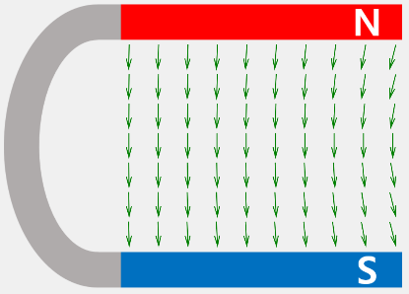
A magnetic field is any region of space where magnetic forces can be felt.

You must also remember that magnetic field lines always go from the north pole to the south pole.

Demonstration of a magnetic field due to a current in a long straight wire

Each end of the wires is connected to a d.c. supply with high current (e.g. a car battery).
Note that to demonstrate the existence of the magnetic field we could use iron filings or small compasses.

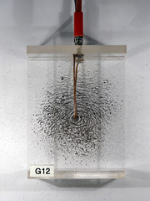 | 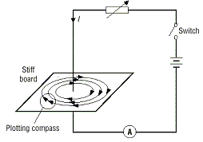

Demonstration of a magnetic field due to a current in a loop

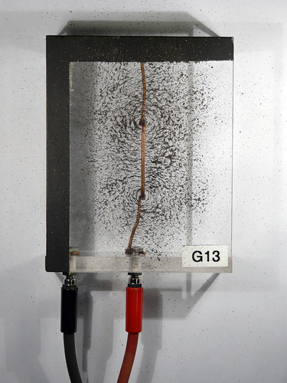 | 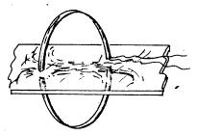

Demonstration of a magnetic field due to a current in a solenoid
A solenoid is a coil of wire whose length is much longer than its radius).

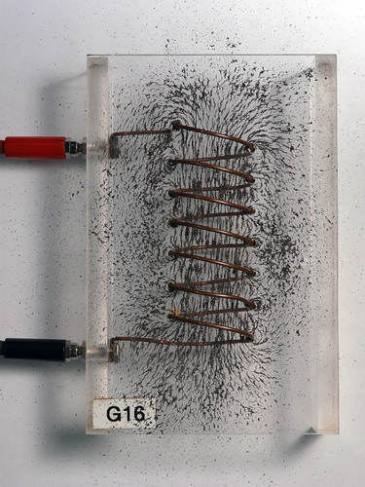 | 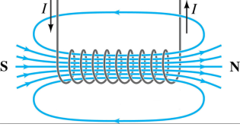

Determining the direction of a magnetic field due to a current in a straight wire

Use the right hand grip rule:
Grip the conductor in your right hand with your thumb pointing in the direction of the current; your fingers now indicate the direction of the magnetic field lines.

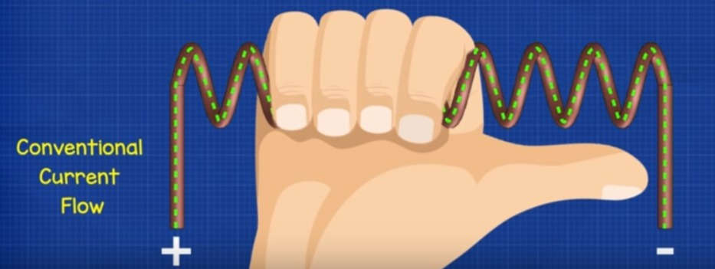

Determining the direction of a magnetic field due to a current in a solenoid
The easiest way of remembering the direction of the magnetic field in a solenoid is to note that when looking into a loop or solenoid, if the current is moving in a clockwise direction then the pole facing you is a south pole.
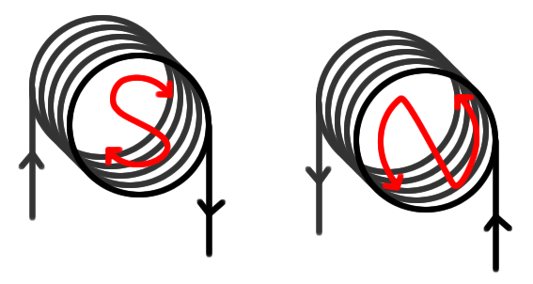
Think CIS - kiss?

To demonstrate the magnetic effect of an electric current: the electromagnet
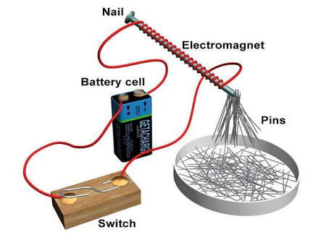
An electromagnet consists of a soft iron core in a solenoid.
When the current is switched on the core acts as a magnet and can be used to pick up nails.

Uses of electromagnets
- Electromagnets can be used in scrap yards to lift cars.
- They are also used in electric motors, loudspeakers and electromagnetic relays (eg in doorbells).

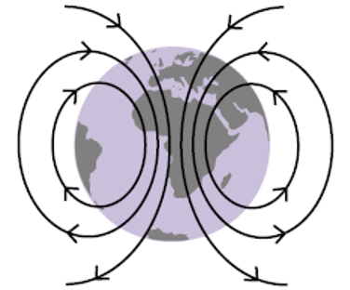
The earth’s magnetic field

- The Earth’s magnetic field can be used for accurate navigation, both by man and animal.
- Flipping of the earth’s magnetic field
- Magnetic fields protect the Earth from dangerous radiation from the sun

Magnets and magnetism – never underestimate the wonder they offer


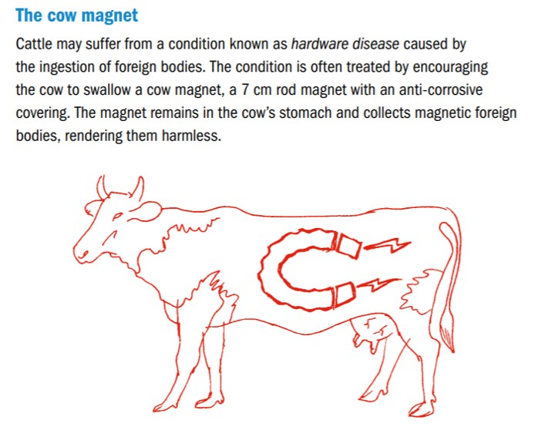
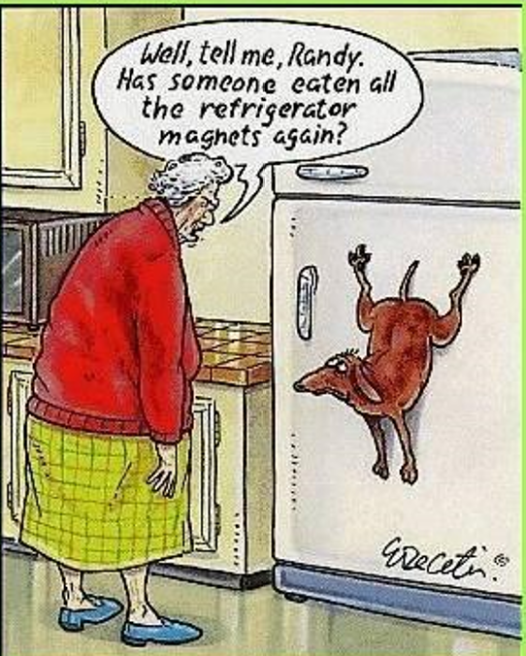
Extra reading

Fatal Attraction: Magnetic Mysteries of the Enlightenment
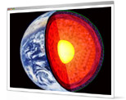
Magnets were associated with sex: the French word aimant means either magnet or lover; William Gilbert, in 1600, coined the vocabulary of male and female poles; magnets could lure lovers or keep a spouse faithful; even now, someone with a magnetic personality can ‘pull’. Such explanations as there were relied on loose phrases such as the ‘power of sympathy’. But the lodestone business was a serious one: magnetic forces (people thought for a while) held the world together, and they certainly kept navigators pointing in the right direction. Edmond Halley, he of the comet, began what became a systematic study of compass variation, and quickly calculated that the Earth was one huge ball of magnetism, and proposed that its interior might not only be hollow, but even populated – an idea that seeped into romance, satire and (long afterwards) science fiction.
Taken from The New Scientist magazine
“Who would not be amazed at this virtue of the stone?”
Augustine

“The diamond is a stone possessed by many among ourselves, especially by jewellers and lapidaries, and the stone is so hard that it can be wrought neither by iron nor fire, nor, they say, by anything at all except goat’s blood. But do you suppose it is as much admired by those who own it and are familiar with its properties as by those to whom it is shown for the first time? Persons who have not seen it perhaps do not believe what is said of it, or if they do, they wonder as at a thing beyond their experience; and if they happen to see it, still they marvel because they are unused to it, but gradually familiar experience [of it] dulls their admiration. We know that the loadstone has a wonderful power of attracting iron. When I first saw it I was thunderstruck, for I saw an iron ring attracted and suspended by the stone; and then, as if it had communicated its own property to the iron it attracted, and had made it a substance like itself, this ring was put near another, and lifted it up; and as the first ring clung to the magnet, so did the second ring to the first. A third and a fourth were similarly added, so that there hung from the stone a kind of chain of rings, with their hoops connected, not interlinking, but attached together by their outer surface. Who would not be amazed at this virtue of the stone, subsisting as it does not only in itself, but transmitted through so many suspended rings, and binding them together by invisible links? Yet far more astonishing is what I heard about this stone from my brother in the episcopate, Severus bishop of Milevis. He told me that Bathanarius, once count of Africa, when the bishop was dining with him, produced a magnet, and held it under a silver plate on which he placed a bit of iron; then as he moved his hand with the magnet underneath the plate, the iron upon the plate moved about accordingly. The intervening silver was not affected at all, but precisely as the magnet was moved backwards and forwards below it, no matter how quickly, so was the iron attracted above. I have related what I myself have witnessed; I have related what I was told by one whom I trust as I trust my own eyes. Let me further say what I have read about this magnet. When a diamond is laid near it, it does not lift iron; or if it has already lifted it, as soon as the diamond approaches, it drops it. These stones come from India. But if we cease to admire them because they are now familiar, how much less must they admire them who procure them very easily and send them to us? Perhaps they are held as cheap as we hold lime, which, because it is common, we think nothing of, though it has the strange property of burning when water, which is wont to quench fire, is poured on it, and of remaining cool when mixed with oil, which ordinarily feeds fire.”
Pliny the Elder (who lived around the same time as Jesus). I love this because it really gives a sense of how ‘unnatural’ this phenomenon is.

SLOP

What is a magnetic field? | A magnetic field is any region of space where magnetic forces can be felt.
Describe an experiment to show the magnetic field due to a current in a solenoid. | See notes
Describe an experiment to show the shape of the magnetic field around a U-shaped magnet. | See notes
Draw a sketch of the magnetic field around a bar magnet.

Draw a sketch of the magnetic field due to a long straight current-carrying conductor.  Your diagram should show the direction of the current and the direction of the magnetic field. | See notes
The diagram shows a U-shaped magnet. Copy the diagram and show on it the magnetic field lines due to the magnet. | Show field lines going in straight lines from north to south.
Give one use of the earth’s magnetic field. | Navigation, protective layer around the earth which deflects dangerous cosmic rays (sometimes called solar winds).
Why does a magnet that is free to rotate point towards the North? | It is the north end of the magnet which is being attracted to the south-end of the Earth’s magnetic field (which is located at what we call the north pole).
A solenoid carrying a current and containing an iron core is known as an electromagnet.  Give one use of an electromagnet. | Electric bell / scrap yard crane / speaker / doorbell.
State one advantage of an electromagnet over an ordinary magnet. | It can be turned on and off.

2: Current in a magnetic field

Student notes

A current-carrying conductor in a magnetic field experiences a force

Why does a current-carrying conductor in a magnetic field experiences a force?

Demonstration
- Set up as shown.
- Turn on the power supply.
- The foil moves up or down, depending on the direction of the current (see next page).

This is the principle of operation of:
- The electric motor
- The moving coil loudspeaker (see diagram below)

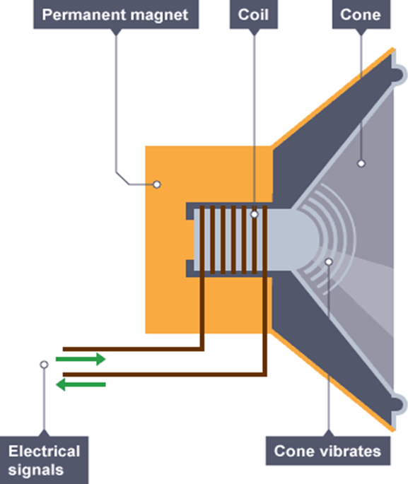
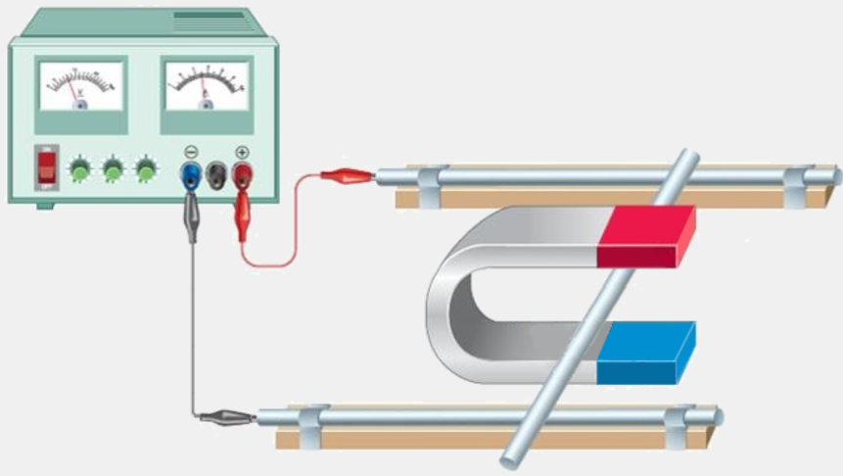

Size of the force experienced by a current-carrying conductor in a magnetic field: F = BIL

It turns out from experiment that the size of the force (F) depends on:
- The size of the current (I),
- The length of the conductor (L)

From the factors mentioned above, we can write that F ∝ IL or F = k IL.
The proportional constant is called the magnetic flux density (B) and is an indicator of how strong the magnetic field is. So F = BIL
F = BIL

The unit of magnetic flux density is the tesla. The symbol for the tesla is T.

Meanwhile, back at the ranch . . .
F = BIL

We can use this relationship to define the tesla: B =$\frac{F}{IL}$
A magnetic flux density of one tesla will cause a current-carrying conductor to experience a force of 1 N per amp per metre.

2004 Question 5 [Ordinary level]  A conductor of length 50 cm is carrying a current of 5 A.  It is placed at right angles to a magnetic field of flux density 3 T.  Calculate the force on the conductor. | L = 0.5 m  I = 5 A  B = 3 T  F = BIL ⇒ F = (3)(5)(0.5) = 7.5 N
2006 [Ordinary level]  Calculate the force on the aluminium foil if its length is 10 cm and a current of 1.5 A flows through it when it is placed in a magnetic field of flux density 3.0 T. | L = 0.1 m  I = 1.5 A  B = 3 T  F = B I l ⇒ F = (3)(1.5)(0.1) = 0.45 N
2022 Question 6 [Higher level]  A current-carrying wire of length 20 cm is placed in a magnetic field.  When a current of 55 mA flows in the wire the maximum force it can experience is 130 μN.  Calculate the magnetic flux density of the field. | F = 130 μN = 130 × 10⁻⁶ N  I = 55 mA = 0.055 A  L = 20 cm = 0.2 m  F = BIL  $B=\frac{F}{IL}=\frac{{130×10}^{-6}}{ 0.055 × 0.2 }$ = 0.0118 T

Direction of the force on a current-carrying conductor in a magnetic field
This is known as Fleming’s Left Hand Rule

(Think “Stick ‘em up! I’m a left-handed FBI agent”!)
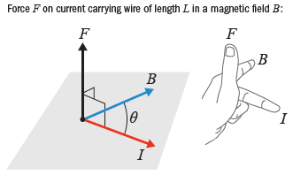

F = Direction of force, represented by thumb
B = Direction of field, represented by first finger (index finger)
I = Direction of current, represented by middle finger

Force on a moving charge in a magnetic field, moving at velocity v

F = Bev

Technically, the formula is F = BQv, but I prefer the above for two reasons:
- Both formulae in this topic can now be remembered as peoples’ names; BIL and Bev.
- The charged particle is usually either an electron (e) or a proton (which has the same charge as an electron).
Note the use of small v for velocity (not to be confused with big V for voltage).

Derivation of F = Bqv

l

Consider a section of conductor of length l through which a current I is flowing.
If q is the charge which carries the current in this section of the conductor, then:
I = q/t, (remember q = It (QuIT?) where t is the time it takes the charge q to travel a distance l).

The average velocity with which the charge flows is given by v = l/t, i.e. l = vt.
Substituting into the primary equation which we have for force (F = BIL), we get
F = B × q/t × vt
i.e. F = Bqv

Force on a charge moving in a circular path due to a magnetic field

The charged particle moving through a magnetic field will move in a circular path so we can use the same formula as is in the Circular Motion chapter to describe its motion:
(again v is velocity).
$$F=\frac{mv^{2}}{r}$$

2014 Question 11 (a)
Give an expression for the momentum of a particle in the cyclotron in terms of the magnetic flux density of the field, the charge on the particle and the radius of its circular path at any instant.

Solution
The word ‘radius’ is the clue that tells us we’re talking about a centripetal force, the term ‘magnetic flux density’ is the clue that tells us that we’re talking about a magnetic force.
Equate the expressions for centripetal and magnetic force and rearrange so that we get mv (momentum) on one side:
Centripetal force = magnetic force$$\frac{mv^{2}}{r}=Bqv$$
Cancel one v on both sides and multiply both sides by r to get rid of the r on the left hand side.
⇒ mv = Bqr
2015 Question 10 (a)
In a cloud chamber an electron travels perpendicular to the direction of a magnetic field of flux density 90 mT and it follows a circular path.
Calculate the radius of the circle when the electron has a speed of 1.45 × 10⁸ m s^{–1}.

Solution
B = 90 ×10⁻³ T
v = 1.45 × 10⁸ m s^{–1}
m_{electron} = 9.1 × 10⁻³¹ kg
q_{electron} = 1.60 × 10⁻¹⁹ C
r = ?
Equating both expressions:
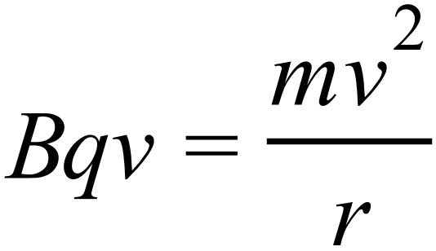 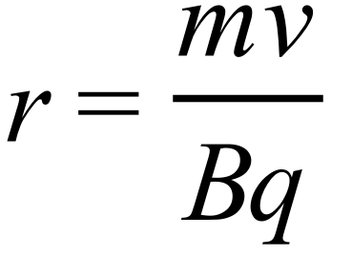 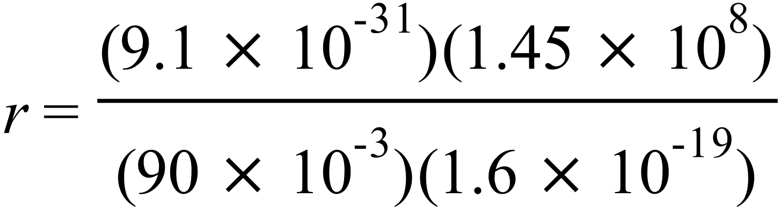 r = 9.16 × 10^{–3} m
2019 Question 9
In a nuclear detector a proton enters a magnetic field of flux density 0.5 T at right angles to the field.
The proton initially follows a circular path of radius 2.3 mm.
Calculate the speed of the proton as it enters the field.

Solution
B = 0.5 T
r = 2.3 × 10⁻³ m
m_{proton} = 1.67 × 10⁻²⁷ kg
q_{proton} = 1.60 × 10⁻¹⁹ C
v = ?

$Bqv =\frac{mv^{2}}{r}$ $\frac{Bq r}{m}=v$ $v=\frac{(0.5)({1.60×10}^{-19})({2.3×10}^{-3})}{{1.67×10}^{-27}}$
v = 1.1 × 10⁵ m s⁻¹

The magnetic force between two current-carrying conductors
Two current carrying conductors will exert a force on each other.
This is the principle on which the definition of the ampere is based (well, sort of. See below).

Definition of the ampere
- The ampere
- is that constant current which, if flowing in
- two
- very long
- parallel wires
- one metre apart
- in a vacuum
- will experience a force of
- 2 x 10⁻⁷ N
- per metre length.

To demonstrate the principle on which the (old) definition of the ampere was based
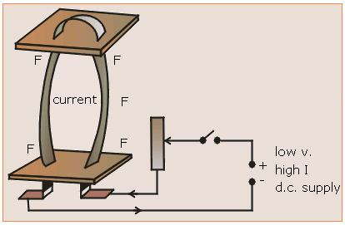
- Connect two parallel conductors (aluminium strips will do nicely) in a circuit as shown.

- Complete the circuit to switch on the current.

- The strips will either move towards each other or repel each other, depending on the direction of the currents.

SLOP

A current-carrying conductor experiences a force when placed in a magnetic field. Name two factors that affect the magnitude of the force. | Strength of magnetic field, size of current flowing, length of conductor in magnetic field.
Name two devices that are based on the principle that a current-carrying conductor in a magnetic field experiences a force. | Motor, galvanometer, loudspeaker.
State the principle on which the definition of the ampere is based. | A current-carrying conductor in a magnetic field experiences a force.
Describe an experiment to demonstrate that a current-carrying conductor in a magnetic field experiences a force. | See notes
Describe an experiment to demonstrate the principle on which the definition of the ampere is based. | See notes
Define the ampere, the SI unit of current. | The ampere is the amount of charge which, if flowing in two very long parallel wires one metre apart in a vacuum will experience a force of 2 × 10⁻⁷ N per metre length.

3: Electromagnetic induction

Student notes
Electromagnetic induction occurs when an emf is induced in a coil due to a changing magnetic flux

We have seen from the last two chapters that electricity and magnetism are inter-linked.
One of the first people to investigate this relationship was the English scientist, Michael Faraday.
He discovered the following:

- If you move a magnet in and out of a coil of wire, a voltage (more properly termed an emf or electromotive force) is created in the coil.
- The quicker you move the magnet (or the coil), the greater the size of the emf.

Demonstrating electromagnetic induction

- Move the magnet in and out of the coil of wire slowly and note a slight deflection.
- Move the magnet quickly and note a greater deflection.

It was later found that the direction of the emf could also be predicted - this lead to what became known as Lenz’s Law. The two laws together are known as the laws of electromagnetic induction:

The laws of electromagnetic induction

- Faraday’s law states that the size of the induced emf is proportional to the rate of change of magnetic flux.
The demonstration above is also accepted as the standard demonstration of Faraday’s law but this is not technically correct because it doesn’t prove that the two variables are proportional to each other – it merely demonstrates the principle underlying it.

- Lenz’s law states that the direction of the induced emf is always such as to oppose the change producing it.

We’ll come back to Lenz’s law after first looking at Faraday’s law in more detail.

Magnetic flux

We would like to calculate the size of this induced emf (or voltage) and we will use Faraday’s law to do this. But first we need to look at one more concept; magnetic flux.

The symbol for magnetic flux is Φ (pronounced “fi” – rhymes with “high”).
The unit of magnetic flux is the weber (Wb)

To introduce the idea of magnetic flux consider an area A in a uniform magnetic field as shown below.
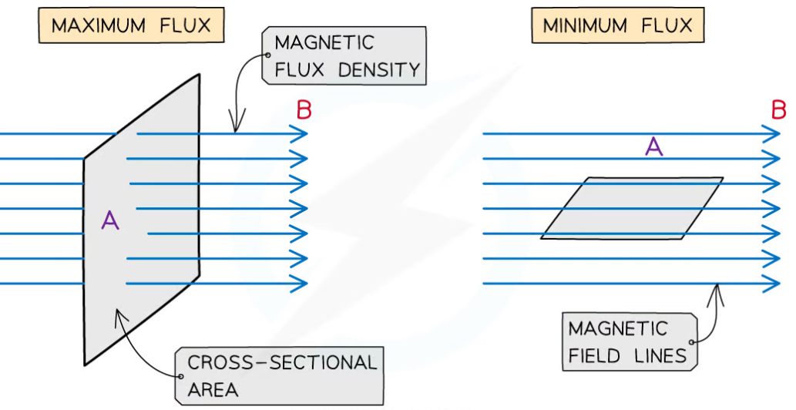
The total magnetic flux (Φ) through this area is defined as the product of B and A, where A is the area that the flux lines are passing through.
For the second diagram on the right this area A is negligible so is considered to be zero.

Φ = BA

Magnetic flux is defined as the product of magnetic flux density and the cross-sectional area perpendicular to the direction of the magnetic flux density.

The magnetic flux can be visualised as the number of magnetic field lines passing through a given area.

Notice that in the first diagram the cross-sectional area that the lines are passing though is a maximum (because the area is perpendicular to the direction of the magnetic field lines), however in the second diagram the cross-sectional area that the lines are passing though is zero.
This is important when it comes to exam questions.

Now we are in a position to calculate the induced emf

Remember Faraday’s law: The size of the induced emf is proportional to the rate of change of flux.
Change in flux corresponds to Final flux – Initial flux.
Induced emf = $\frac{final flux – initial flux}{time taken}$

$$E= \frac{dΦ}{dt}$$
Remember when we used Q = (m)(c)(Δθ) for heat energy?
Δθ (pronounced “delta theta”) referred to the change in temperature
Similarly we could refer to change in flux as $ΔΦ$ (“delta fi”) or just $dΦ$.

The Formula & Tables book uses $dΦ$ but that version can be confusing if you don’t remember what $dΦ$ means so we will use the longer version in word format:

Induced emf = $[\frac{final flux – initial flux}{time taken}]$

Note that this formula assumes the coil has only one turn. If there are N turns then the formula becomes:
Induced emf = $\left(N\right)[\frac{change in flux}{time taken}]$

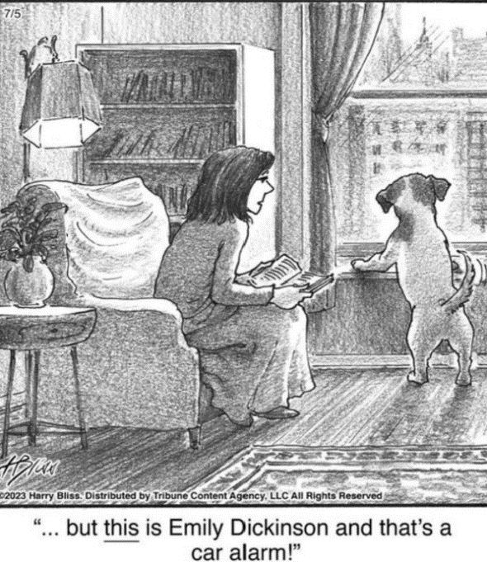

Me explaining electromagnetic induction in class

Calculating the induced emf - straightforward questions

Induced emf = $\left(N\right)[\frac{change in flux}{time taken}]$

2005 Higher level  A square coil of side 5 cm lies perpendicular to a magnetic field of flux density 4.0 T. The coil consists of 200 turns of wire.  What is the magnetic flux cutting the coil? | A = (0.05)² = 0.0025  B = 4.0 T  Φ = BA = (4)(0.0025) = 0.01 Wb
2016 Higher level  A coil consists of 150 turns of wire.  It takes 3 ms for the magnetic flux cutting the coil to increase by 4.5 × 10^{–4} Wb.  Calculate the average emf induced in the coil during the 3 ms time period | Change in flux = 4.5 × 10^{–4} Wb  N = 150  t = 3 × 10⁻³ s  Induced emf = $\left(N\right)[\frac{change in flux}{time taken}]$  Induced emf = $\left(150\right)[\frac{{4.5 ×10}^{-4}- 0}{{3×10}^{-3}}]$  Induced emf = 22.5 V
2006 Higher level  What is the emf induced in the coil when the magnetic flux cutting a coil of wire (containing 5000 turns) changes by 8 × 10^{–4} Wb in 0.1 s? | Change in flux = 8 × 10^{–4} Wb  N = 5000  t = 0.1 s  Induced emf = $\left(N\right)[\frac{change in flux}{time taken}]$  Induced emf = $\left(5000\right)[\frac{8×{10}^{-4}}{0.1}]$ = 40 V
2009 Higher level  What is the average emf induced in a coil of 20 turns when the magnetic flux cutting it decreases from 2.3 Wb to 1.4 Wb in 0.4 s? | Initial flux = 2.3 Wb  Final flux = 0.4 Wb  N = 20  t = 0.4 s  Induced emf = $\left(N\right)[\frac{change in flux}{time taken}]$  = $\left(20\right)[\frac{2.3 – 1.4}{0.4}]$  = 45 V

I like the sound of science. I like how words I don’t understand and can’t pronounce explain things I can’t even imagine.
Adapted from Wonder, by R J Palacio

Calculating the induced emf - slightly trickier questions

A square coil of side 5 cm lies perpendicular to a magnetic field of flux density 4.0 T. The coil consists of 200 turns of wire.  Calculate the magnitude of the average e.m.f. induced in the coil while it is being rotated.  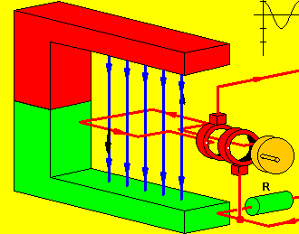 | A = (0.05)² = 0.0025  Φ = BA = (4)(0.0025) = 0.01 Wb  When the red coil is vertical there are no magnetic flux lines passing through the coil (the area is 0). But when the coil is horizontal as shown then the magnetic flux is a maximum because the area is a maximum (flux = BA)}  Induced emf = $\left(N\right)[\frac{final flux – initial flux}{time taken}]$  E = $\left(200\right)[\frac{0.01 – 0}{0.2}]$ E = 10 V
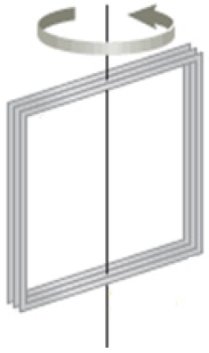  2018 Higher level  A square coil of 40 turns with a side of length 20 cm is perpendicular to a magnetic field of flux density 50 mT.  What is the average emf induced in the coil when it is rotated through 90° in ¼ of a second? | A = (0.2)²  B = 50 × 10⁻³ T  Φ = BA = (50 × 10⁻³)(0.2)² = 2 × 10⁻³ webers  Induced emf = $\left(N\right)[\frac{change in flux}{time taken}]$  Induced emf = $\left(40\right)\left[\frac{{(2 ×10}^{-3})- 0}{0.25}\right]$ = 0.32 V
2008 Higher level
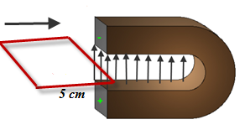
A metal loop of wire in the shape of a square of side 5 cm enters a magnetic field of flux density 8 T.
The loop is perpendicular to the field and is travelling at a speed of 5 m s^{–1}.
- How long does it take the loop to completely enter the field?
- What is the magnetic flux cutting the loop when it is completely in the magnetic field?
- What is the average emf induced in the loop as it enters the magnetic field?
Solution
- How long does it take the loop to completely enter the field?
$time=\frac{distance}{speed}=\frac{.05}{5}$ = 0.01 seconds

- What is the magnetic flux cutting the loop when it is completely in the magnetic field?
Φ = BA = (8)(0.05)² = 0.02 webers
{the area in this case corresponds to the area of the loop, which is a square of side 0.05 m}

- What is the average emf induced in the loop as it enters the magnetic field?
The area the flux lines are passing through is 0 when the coil is outside (so magnetic flux is 0).
But when the coil is fully inserted then the flux is a maximum (0.02 Wb)

Induced emf = $\frac{final flux – initial flux}{time taken}$ = $\frac{0.02-0}{0.01}$ = 2 Volts

Lenz’s law

Lenz’s law states that the direction of the induced emf is always such as to oppose the change producing it.

Explanation
We know that when a magnet and coil move relative to each other, an emf is induced.
Now if the coil is a conductor the induced emf will drive a current around the coil.
This current has a magnetic field associated with it.
Changing flux ⇒ induced emf ⇒ induced current ⇒ magnetic field

The direction of this induced magnetic field will always be such as to oppose the change which caused it.

Demonstrating Lenz’s law

(i) Magnet, plastic and copper tubes*
Apparatus
Plastic pipe
Magnet
Copper pipe

Magnet
Copper pipe, plastic pipe, stopwatch, strong neodymium magnet, piece of neodymium, or iron, (same size as magnet).
Procedure
Drop the neodymium magnet down both tubes and compare the time taken for each for each.
Observation
The time taken for the magnet to fall down through the copper tube is much longer than the time taken for the magnet to fall down the plastic tube.
Explanation
The falling magnet creates a changing magnetic flux in both tubes.
An emf is therefore induced in both tubes.
But current flows in only the copper tube because this is the only material that is a conductor.
This induced current generates a magnetic field which oppose the motion of the falling magnet.

Demonstrating Lenz’s law
(ii) Magnet and aluminium ring

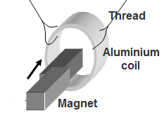
Apparatus
Aluminium ring, magnet, thread, retort stand.
Procedure
- Move one end of the bar magnet towards and into the ring. The ring moves away from the magnet.
- Hold the magnet in the ring and quickly pull it away. The ring follows the magnet.
Observation
When the magnet moves, the ring responds by moving in the same direction.
Explanation
The moving magnet causes a changing magnetic flux in the ring.
An emf is therefore induced in the ring and this emf in turn generates a current.
This current creates a magnetic field that exerts a force to oppose the motion of the magnet. The magnet exerts an equal and opposite force on the ring and so the ring moves foward.

Electric generators
Let’s take a look at that very first diagram again:
Here mechanical energy is being converted to electrical energy.
Would you believe that it is this simple action which is responsible for almost all our electricity generation (solar energy being the main exception)?
If you follow the electric wires in your house back to their source you will (eventually) find at the other end a generating station which has either a magnet moving in and out of a coil of wire, or more likely, a coil of wire rotating in a magnetic field.

An electric generator is a device that converts mechanical energy to electrical energy
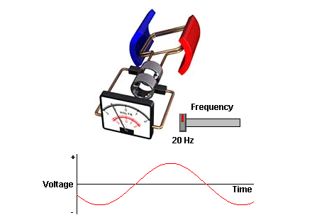
Note that in the diagram on the right the voltage is changing direction in a sine-wave fashion.
The generators in power plants are designed to change direction 50 times a second (frequency = 50 Hertz).
Because the voltage is responsible for the current, it follows that the current also changes direction 50 times a second.

The microphone
A microphone converts sound waves into an electrical signal.

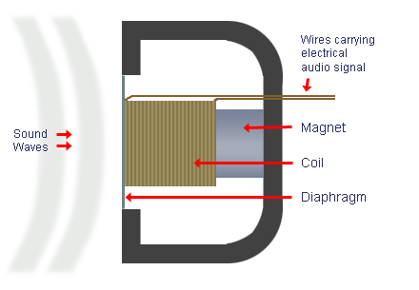

Alternating current (a.c.)

Alternating current is current which continually changes direction.
Mains electricity consists of current which changes direction between 40 and 50 times a second.

To demonstrate alternating current
Set up as shown. Notice that only one diode A lights up.
Reverse the polarity of the d.c. power supply and notice that only diode B lights up.
Replace the power supply with an a.c. power supply. Note that both diodes seems to be lighting but if you look at a video of the setup through a slow motion app on your phone you will see that the diodes are flashing in alternate cycles.

Comparing alternating voltage and current to direct voltage and current
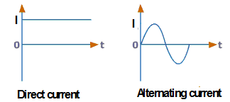
I_{rms} = $\frac{I_{max}}{\sqrt{2}}$
V_{rms} = $\frac{V_{max}}{\sqrt{2}}$

We do this because the r.m.s. of the alternating current will have the same power output as a direct current of the same magnitude.
e.g. If the r.m.s. value of an alternating current is 2 A, it will the same heating effect as 2 A direct current.

2010 Question 5 [Higher level]  The peak voltage of an a.c. supply is 300 V. Calculate its rms voltage. | V_{max} = 300 V  V_{rms} = $\frac{V_{max}}{\sqrt{2}}$ = $\frac{300}{\sqrt{2}}$ = 212 V
[2016]  Explain why it is necessary to use rms values when comparing a.c. and d.c. electricity. | To make the power output equivalent between a.c. and d.c.

Mutual induction

An alternating current in one coil results in an induced emf in a second nearby coil.
Changing emf (in first coil) ⇒ changing current (in first coil) ⇒ changing magnetic flux (in first coil)
⇒ induced emf (in second coil).

This in turn can induce a current in the second coil if the second circuit is complete.

To demonstrate mutual induction
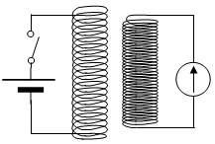
Procedure
- Set up two coils side by side as shown.
- Close the switch in the first coil – a deflection is seen on the galvanometer in the second coil.
- Open the switch – a larger deflection is observed.

Explanation
At the make and break of the circuit there is a change in the magnetic flux linking the coils and so an emf is induced in the secondary coil.
The deflection is greater at the break because the current drops more quickly than it increases.

Mutual induction and the transformer

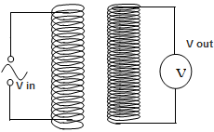
A transformer consists of two adjacent coils of wire with a soft iron core passing through both.
We’ll come back to the iron core later.

Uses of transformers
Transformers are used in generating stations to step up the voltage from about 20 kV to anything up to 400 kV (can you remember why?)
This has then to be dropped down to 230 Volts before it enters the home.
Many household appliances run on lower voltages again, and so a second transformer is required. This is usually inside the appliance (e.g. a radio).

First coil |  | Second coil
Constantly changing emf  ⇒ constantly changing current  ⇒ constantly changing magnetic field | ⇒ | constantly changing induced emf  ⇒ constantly changing current (if it’s a complete circuit)

To demonstrate the action of a transformer
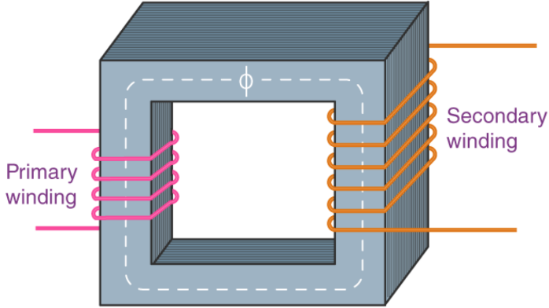
Procedure
- Set up as shown.
- Switch on the a.c. supply (left hand side).

Observation
A continuous reading is obtained fron the voltmeter on the right hand side.

The size of the induced emf may be increased by:
- Having the coils nearer each other
- Winding the coils on the same soft iron core as shown above.

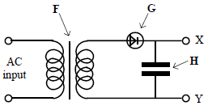
2013 Question 8 (a) [Higher Level]
- The diagram shows a circuit used in a charger for a mobile phone.Name the parts labelled F, G and H.
- Describe the function of G in this circuit.
- Sketch graphs to show how voltage varies with time for
the input voltage and the output voltage, V_{XY}.

- Name the parts labelled F, G and H.
F: transformer / iron core (it’s not clear if the arrow is pointing specifically to the iron core or to the entire transformer).
G: diode, H: capacitor

- Describe the function of G in this circuit.
It acts as a rectifier: it converts a.c. to d.c.

- Sketch graphs to show how voltage varies with time for the input voltage and the output voltage

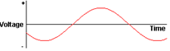
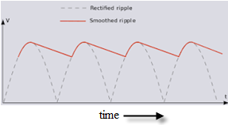
Input voltage Output voltage

The relationship between v_{out} and v_{in} for a transformer

The relationship between voltage across the secondary coil (Vs) and voltage across the primary coil (Vp) is determined by the ratio of the number of turns on the secondary coil (Ns) to the number of turns on the primary coil (Np)
$$\frac{V_{S}}{V_{P}}=\frac{N_{S}}{N_{P}}$$

Vs = voltage across the secondary coil, Vp = voltage across the primary coil
Ns = Number of turns in secondary, Np = Number of turns in primary coil

Note
If the voltage is increased, the transformer is called a ‘step-up transformer’
If the voltage is decreased, the transformer is called a ‘step-down transformer’

2017 Question 5 [Ordinary level]  There are 150 turns in the primary coil of a transformer and 3000 turns in the secondary coil.  Calculate the output voltage when 12 V a.c. is connected across the primary coil. | Vs = ?, Vp = 12 V, Ns = 3000, Np = 150,  $\frac{Vs}{Vp}=\frac{Ns}{Np}$ $V_{s}=\frac{N_{s}}{N_{p}}V_{p}$  $V_{s}=\frac{3000}{150}(12)= 240 V$
2002 Question 9 [Ordinary level]  The mains electricity supply (230 V) is connected to the input coil of a transformer which has 400 turns. The output coil has 100 turns. What is the reading on the voltmeter connected to the secondary coil? | Vp = 230 V, Vs = ?, Ns = 100, Np = 400  $\frac{Vs}{Vp}=\frac{Ns}{Np}$ $V_{s}=\frac{N_{s}}{N_{p}}V_{p}$  $V_{s}=\frac{100}{400}(230)= 57.5 V$

A transformer attached to an electricity pole
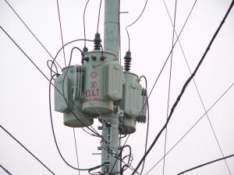
This transformer converts high voltages into low voltages which in turn is supplied to the home. The electrical energy was transferred at high voltage because high voltage corresponds to low current which in turn corresponds to low heat loss. However this hight voltage/low current needs to be converted into high current/low voltage in order to run most household appliances.

Self-induction
This is tricky. If it wrecks your head then just skip it and hope that it doesn’t appear on the exam

A changing emf in a coil induces a changing magnetic field in the coil itself.
This changing magnetic field in turn induces a second emf (in the coil itself) which is opposite in direction to the driving emf.

This induced emf is known as back-emf (because it is acting ‘backwards’)

Changing emf ⇒ changing current ⇒ changing magnetic field ⇒ induced changing emf (in opposite direction to original) ⇒ induced changing current (in opposite direction to original) {all in the same coil}

To demonstrate self-induction (Back emf)
Apparatus
6 V a.c. power supply, coil of wire with 1200 turns, soft iron core, 6 V filament lamp.
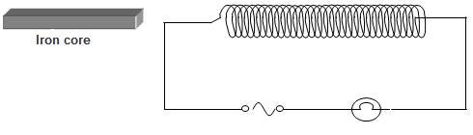

Procedure
- Connect the bulb, coil and a.c. supply in series.
- Switch on the power supply. The lamp lights.
- Insert the iron core into the coil. The lamp becomes dimmer.

Explanation
The a.c. produces a changing magnetic field in the coil.
This induces an emf and hence a current that opposes the applied current.
The iron core increases the magnetic flux and hence the induced opposing current is increased.
The resultant current in the circuit is reduced and the bulb becomes dimmer.

Note
If this circuit is set up using a d.c. power supply, no dimming occurs with the core in the coil as there is no changing magnetic field.

It should now be apparent that a coil of wire can be used to reduce alternating current in the same way that a normal resistor is used to reduce direct current.
The coil, when used in this fashion, is known as an inductor: an inductor is an electrical component used to reduce the flow of alternating current.
An example of an inductor is the dimmer switch used in stage lighting.

SLOP

Explain the term emf | emf stands for electromotive force. It is a potential difference applied to a full circuit.
What is electromagnetic induction? | Electromagnetic Induction occurs when an emf is induced in a coil due to a changing magnetic flux.
A magnet and a coil can be used to produce electricity.
How would you demonstrate this?
A coil of wire is connected to a sensitive galvanometer.  What is observed when the magnet is moved towards the coil?  Explain why this occurs. | The needle in the galvanometer deflects.  An emf is induced in the coil of wire, which in turn produces a current which moves the needle.
Describe what happens when the speed of the magnet is increased. | There is a greater deflection of the needle.
How does Faraday’s experiment show that a changing magnetic field is required to generate electricity? | Current stopped whenever the magnet was motionless // electricity is only generated when the magnet or coil is moving.
What name is given to the generation of electricity discovered by Michael Faraday? | Electromagnetic induction
What energy conversions takes place in Faraday’s experiment | Kinetic to electric
State Faraday’s law of electromagnetic induction. | Faraday’s Law states that the size of the induced emf is proportional to the rate of change of flux.
State Lenz’s law of electromagnetic induction. | Lenz’s Law states that the direction of the induced emf is always such as to oppose the change producing it.
Describe an experiment to demonstrate electromagnetic induction. | See notes
Describe an experiment to demonstrate Faraday’s law. | See notes
A light aluminium ring is suspended from a long thread. When a strong magnet is moved away from it, the ring follows the magnet.  Explain why. | Current flows in the ring and the direction of the associated magnetic field is in such a direction as to oppose the change which caused it. Therefore the ring follows the magnet.
What would happen if the magnet in the previous question were moved towards the ring? | The ring would be repelled.
Define magnetic flux. | Magnetic flux is defined as the product of magnetic flux density and area.
Sketch a voltage-time graph of the 230 V supply. | Labelled axes: time on the horizontal and voltage on the vertical.
Electricity produced in a generating station is a.c. What is meant by a.c.? | Alternating current
Sketch a graph to show the relationship between current and time for alternating current | Axes labelled (I and t),sinusoidal curve (at least one full wave)
Sketch a graph to show the relationship between current and time for direct current.

What is a diode? | A diode is a device that allows current to flow in one direction only
Give an example of a device that contains a rectifier. | Radio, television, computer, battery charger, mobile phone charger.
Name a device that is based on electromagnetic induction. | Dynamo, generator, induction motor, transformer, dynamo
What is a transformer used for? | To increase or decrease voltage.
Name two devices that use transformers. | Computer, radio, TV, doorbell, washing machine, mobile phone chargers, power supply, etc.
How is the iron core in a transformer designed to make the transformer more efficient? | It has a laminated core.
The efficiency of a transformer is 90%. What does this mean? | 10% of the power in is lost.
State one energy conversion that takes place in an electrical generator. | Kinetic to electric.

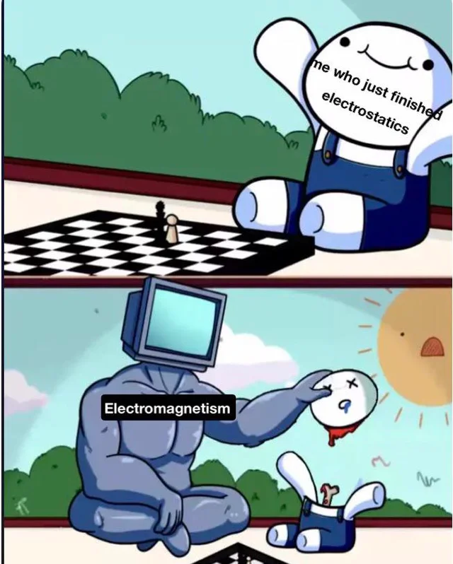

Naming of Parts

Naming of Parts is a wonderful poem by Henry Reed - it contrasts a lesson in military weapons with a flowering plant.
My classroom looks out on a flower garden and I often think of this poem whenever I spot another student gazing wistfully out the window as I waffle on about the finer points of electromagnetic induction.

Another teacher has created her own adaptation of Naming of Parts and I am including it here with the kind permission of the author.

Naming of Parts by Henry Reed | Induced emf by Phoebe Wales
Today we have naming of parts. Yesterday,  We had daily cleaning. And tomorrow morning,  We shall have what to do after firing. But today,  Today we have naming of parts. Japonica  Glistens like coral in all of the neighboring gardens,  And today we have naming of parts.  This is the lower sling swivel. And this  Is the upper sling swivel, whose use you will see,  When you are given your slings. And this is the piling swivel,  Which in your case you have not got. The branches  Hold in the gardens their silent, eloquent gestures,  Which in our case we have not got.  This is the safety-catch, which is always released  With an easy flick of the thumb. And please do not let me  See anyone using his finger. You can do it quite easy  If you have any strength in your thumb. The blossoms  Are fragile and motionless, never letting anyone see  Any of them using their finger.  And this you can see is the bolt. The purpose of this  Is to open the breech, as you see. We can slide it  Rapidly backwards and forwards: we call this  Easing the spring. And rapidly backwards and forwards  The early bees are assaulting and fumbling the flowers  They call it easing the Spring.  They call it easing the Spring: it is perfectly easy  If you have any strength in your thumb: like the bolt,  And the breech, and the cocking-piece, and the point of balance,  Which in our case we have not got; and the almond-blossom  Silent in all of the gardens and the bees going backwards and forwards,  For today we have naming of parts. | To-day we have induced emf. Yesterday,  We had motor effect. And tomorrow morning,  We shall have eddy current braking. But to-day,  To-day we have induced emf. Japonica  Glistens like coral in all of the neighbouring gardens,  And today we have induced emf.  This is the flux density. And this  Is the flux, whose use you will see,  When you differentiate it with respect to time. And this is the cosine of the angle,  Which in your case you don’t need to do. The branches  Hold in the gardens their silent, eloquent gestures,  Which in your case you don’t need to do.  This is Lenz’s law, which is just an addition  To what Faraday had already said. And please do not let me see  Anyone using the wrong units. You can derive them quite easily  from SI units. The blossoms  Are fragile and motionless, never letting anyone see them  Using the wrong units.  And this you can see is how quickly flux changes. The purpose of this  Is to calculate the emf. We can apply it  To an isolated wire: this creates  A pd between terminals. And rapidly backwards and forwards  The early bees are assaulting and fumbling the flowers:  A pd between terminals.  They call it Fleming’s right hand rule: it is perfectly easy  If you have any spatial awareness: take your right thumb,  And first finger, and second finger, and the directions they point,  Clearly give you the answer; and the almond-blossom  Silent in all of the gardens and the bees going backwards and forwards,  For to-day we have induced emf.

EXAM QUESTIONS 2002 – 2022
Higher and Ordinary Level

Magnets and magnetism: Ordinary level questions

2019 Question 12 (c) [Ordinary Level]
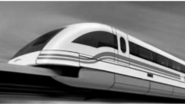
Magnetically levitated trains (known as maglev trains) use magnets under their carriages to float above the magnetic tracks.
Like poles repel, and this is the property of magnets that is used in maglev trains.

- State one other property of magnets.
- What is meant by a magnetic field?
- Describe an experiment to plot the magnetic field of a bar magnet.
- State one other use of magnets.

2016 Question 12 (b) [Ordinary Level]
The diagram shows a bar magnet.

- Copy the diagram and show on it the magnetic field lines around the magnet.
- Describe an experiment to plot the magnetic field lines around the magnet.
- Name a metal that is attracted to a magnet.
- State two practical uses of a magnet.

2021 Question 14 (c) [Ordinary Level]
Magnetism is the force exerted by magnets when they attract or repel each other.
- What is a magnetic field?
- Describe an experiment to plot the magnetic field around a bar magnet.
- Draw a diagram to show the magnetic field around a current‐carrying conductor.
- How could a student show that a current‐carrying conductor experiences a force in a magnetic field?
- State one use of magnets.

2013 Question 8 (b) [Ordinary Level]
- A magnetic field exists about a current-carrying conductor.
What is a magnetic field?
- Describe an experiment to show that a long straight wire carrying a current has a magnetic field.
- Sketch the magnetic field.
- Give an application of the magnetic field due to a current.

2006 Question 10 (b) [Ordinary Level]
- What is a magnetic field?
- Describe an experiment to show the magnetic field due to a current in a solenoid.
- A solenoid carrying a current and containing an iron core is known as an electromagnet.
Give one use of an electromagnet.
- State one advantage of an electromagnet over an ordinary magnet.

Current in a magnetic field: Ordinary level questions

2003 Question 9 [Ordinary Level]
- What is a magnetic field?
- The earth has a magnetic field. Give one use of the earth’s magnetic field.
- Hans Oersted discovered the magnetic effect of an electric current in 1820 while demonstrating electricity to his students. Describe how you would demonstrate the magnetic effect of an electric current.
- Draw a sketch of the magnetic field around a straight wire carrying a current. Your diagram should show the direction of the current and the direction of the magnetic field.
- In an experiment, a thin light conductor is placed between the poles of a U-shaped magnet as shown in the diagram.
Describe what happens when a current flows through the conductor.
- Name two devices that are based on the effect demonstrated in this experiment.
- What would happen if (i) a larger current flowed in the conductor, (ii) the current flowed in the opposite direction through the conductor?

2002 Question 12 (d) [Ordinary Level]
- The diagram shows a U-shaped magnet. Copy the diagram and show on it the magnetic field lines due to the magnet.
- Describe an experiment to demonstrate that a current-carrying conductor in a magnetic field experiences a force.
- List two factors that affect the size of the force on the conductor.
- Name one device that is based on the principle that a current-carrying conductor in a magnetic field experiences a force.

2010 Question 11 [Ordinary Level]
Read this passage and answer the questions below.
In 1819 the Danish physicist Hans Christian Oersted discovered that an electric current flowing through a wire deflected a compass needle.
A year later the Frenchman François Arago found that a wire carrying an electric current acted as a magnet and could attract iron filings. Soon his compatriot André-Marie Ampère demonstrated that two parallel wires were attracted towards one another if each had a current flowing through it in the same direction. However, the wires repelled each other if the currents flowed in the opposite directions.
Intrigued by the fact that a flow of electricity could create magnetism, the great British experimentalist Michael Faraday decided to see if he could generate electricity using magnetism. He pushed a bar magnet in and out of a coil of wire and found an electric current being generated. The current stopped whenever the magnet was motionless within the coil.
- Who discovered that an electric current can deflect a compass needle?
- What did Arago discover?
- What happens when currents flows in the same direction in two parallel wires?
- How could two parallel wires be made to repel each other?
- Draw a sketch of the apparatus Michael Faraday used to generate electricity.
- What name is given to the generation of electricity discovered by Michael Faraday?
- What energy conversions that take place in Faraday’s experiment
- How does Faraday’s experiment show that a changing magnetic field is required to generate electricity?

2009 question 9 [Ordinary Level]
- A magnetic field exists in the vicinity of a magnet.
What is a magnetic field?
- Describe an experiment to show the shape of the magnetic field around a U-shaped magnet.
- The diagram shows a compass placed near a wire connected to a battery and a switch.
Why happens to the compass when the switch is closed?
- What does this tell you about an electric current?
- What happens to the compass when the switch is opened?
- The wire is then placed between the poles of a U-shaped magnet, as shown in the diagram.
Describe what happens to the wire when a current flows through it.
- What would happen if the current flowed in the opposite direction?
- Name two device6s that are based on this effect.

2017 Question 9 [Ordinary Level]
Magnetic fields can be detected near a magnet or a current-carrying conductor.
- What is a magnetic field?
- State one example of a good conductor and one example of a good insulator.
- Name the unit of voltage.

The diagram below shows a wire placed between the poles of a U-shaped magnet.
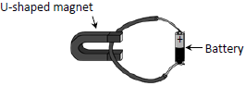

- What happens to the wire when current flows through it?
- What happens when the direction of the current is reversed?
- Name one device based on this effect.

The wire is then disconnected from the battery and connected to a sensitive voltmeter.
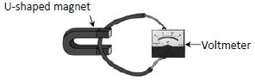

- What is observed on the voltmeter when neither the wire nor the magnet move?
- What is observed on the voltmeter when either the wire or the magnet is moved?
- Name a scientist whose law is associated with this phenomenon?
- Magnetism is one effect associated with an electric current.
- Name one other effect.

2006 Question 10 (a) [Ordinary Level]
The diagram shows an experiment to demonstrate that a current-carrying conductor experiences a force in a magnetic field. A strip of aluminium foil is placed at right angles to a U-shaped magnet. The foil is connected in series with a battery and a switch.
When the switch is closed the aluminium foil experiences an upward force.
- Name a device based on this effect.
- Describe what will happen if the current flows in the opposite direction.
- Describe what will happen if a larger current flows through the aluminium foil.
- Describe what will happen if the aluminium foil is placed parallel to the magnetic field.
- Calculate the force on the aluminium foil if its length is 10 cm and a current of 1.5 A flows through it when it is placed in a magnetic field of flux density 3.0 T.

2023 Question 14 (d) [Ordinary level]
A current-carrying conductor has a magnetic field around it.
- What is a magnetic field?
- Describe a laboratory experiment to plot the magnetic field around a current-carrying conductor.
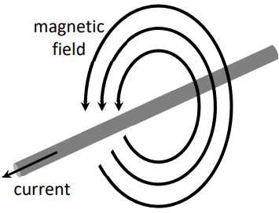
- When a current-carrying conductor is placed in an external magnetic field, it experiences a force.
The magnitude of the force F is proportional to the magnitude of the magnetic flux density B. The force may be calculated using the formula F = IlB.
A straight piece of wire of length 1.8 m carrying a current of 3 A experiences a maximum force of 11 N when it is placed in a uniform magnetic field.
Calculate the magnetic flux density.

- Magnetic flux density is an example of a vector quantity.
Name another example of a vector quantity.

Current in a magnetic field: Higher level questions

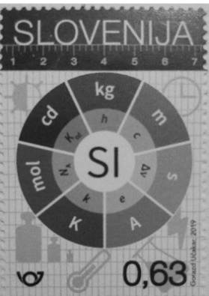
2020 Question 12 (d) [Higher level]
In May of 2019 the definition of the ampere, the SI unit of current, was changed. It is now defined in terms of the value of e, the elementary charge.
- What is current?
- Calculate the current flowing when a mole (6.0 × 10²³) of electrons passes a point in 30 minutes.

The previous definition of the ampere was based on the phenomenon of two parallel current‐carrying conductors exerting a force on each other.
- Explain why this phenomenon occurs.
- Describe a laboratory experiment to demonstrate this phenomenon.

2019 Question 9 [Higher level]
(a)
- Both a moving charge and a conductor carrying an electric current experience a force in a magnetic field. Explain the underlined terms.
- Describe an experiment to demonstrate that a current‐carrying conductor experiences a force in a magnetic field.
- When would a current‐carrying conductor in a magnetic field not experience a force?

(b)
A straight wire of length 3 cm was placed perpendicular to a magnetic field of uniform magnetic flux density B. The force F on the wire was measured for a series of values of current I flowing in the wire.
The following data were recorded.
I (A) | 0.5 | 1.0 | 1.5 | 2.0 | 2.5 | 3.0 | 3.5
F (mN) | 10 | 18 | 31 | 39 | 50 | 59 | 68

- Write down an expression for the force F on the current‐carrying wire in terms of I, B and the length l of the wire.
- Plot a graph on graph paper of force against current.
- Calculate the slope of the graph and use it to calculate the magnetic flux density of the field.

(c)
- Starting with the expression for the force that you wrote in part (b), derive the expression F = qvB for the force F acting on a charge q travelling at a velocity v perpendicular to a magnetic field of flux density B.
- In a nuclear detector a proton enters a magnetic field of flux density 0.5 T at right angles to the field.
The proton initially follows a circular path of radius 2.3 mm.
Calculate the speed of the proton as it enters the field.

Electromagnetic induction: Ordinary level questions

2015 Question 12 (d) [Ordinary Level]
A solenoid (long coil of wire) is connected to a battery as shown.
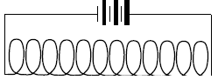
- Copy the diagram into your answer book and draw the magnetic field in and around the solenoid.
- Explain the term electromagnetic induction.
- A magnet and a solenoid can together be used to produce electricity.
Describe, with the aid of a diagram, how this can be done.

2014 Question 9 [Ordinary Level]
- A magnetic field exists around a current-carrying conductor.
What is a magnetic field?
- How does a compass indicate the direction of a magnetic field?
- Describe an experiment to show that there is a magnetic field around a current-carrying conductor and sketch the field lines around the conductor.
- Sketch the magnetic field around a bar magnet.

- A coil of wire is connected as shown in the diagram to a galvanometer.
A bar magnet is placed near the coil.
What is observed when the magnet is moved towards the coil?
- What is observed when the magnet is stationary?
- Explain these observations.
- How would increasing the speed of movement of the magnet alter the observations?

2010 Question 11 [Ordinary Level]
Read this passage and answer the questions below.
In 1819 the Danish physicist Hans Christian Oersted discovered that an electric current flowing through a wire deflected a compass needle.
A year later the Frenchman François Arago found that a wire carrying an electric current acted as a magnet and could attract iron filings. Soon his compatriot André-Marie Ampère demonstrated that two parallel wires were attracted towards one another if each had a current flowing through it in the same direction. However, the wires repelled each other if the currents flowed in the opposite directions.
Intrigued by the fact that a flow of electricity could create magnetism, the great British experimentalist Michael Faraday decided to see if he could generate electricity using magnetism. He pushed a bar magnet in and out of a coil of wire and found an electric current being generated. The current stopped whenever the magnet was motionless within the coil.
- Who discovered that an electric current can deflect a compass needle?
- What did Arago discover?
- What happens when currents flows in the same direction in two parallel wires?
- How could two parallel wires be made to repel each other?
- Draw a sketch of the apparatus Michael Faraday used to generate electricity.
- What name is given to the generation of electricity discovered by Michael Faraday?
- What energy conversions that take place in Faraday’s experiment
- How does Faraday’s experiment show that a changing magnetic field is required to generate electricity?

2011 Question 9 (a) [Ordinary Level]
State Faraday’s law of electromagnetic induction.
A coil of wire is connected to a sensitive meter, as shown in the diagram.
- What is observed on the meter when the magnet is moved towards the coil?
- What is observed on the meter when the magnet is stationary in the coil?
- Explain these observations.
- How would changing the speed of the magnet affect the observations?

2005 Question 9 [Ordinary Level]
- What is a magnetic field?
- Draw a sketch of the magnetic field around a bar magnet.
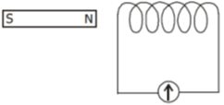
- Describe an experiment to show that a current carrying conductor in a magnetic field experiences a force.
- List two factors that affect the size of the force on the conductor.
- A coil of wire is connected to a sensitive galvanometer as shown in the diagram.
What is observed when the magnet is moved towards the coil?
- Explain why this occurs.
- Describe what happens when the speed of the magnet is increased.
- Give one application of this effect.

2008 Question 12 (d) [Ordinary Level]
- What is electromagnetic induction?
- A magnet and a coil can be used to produce electricity.
- How would you demonstrate this?
- The electricity produced is a.c. What is meant by a.c.?

2018 Question 12 (d) [Ordinary Level]
- What is electromagnetic induction?
- Explain how you would use a magnet and a coil, as shown above, to produce electricity.
- How would you know that electricity is being produced?
- How could you increase the magnitude of the electricity produced?
- The apparatus in the diagram can be used to produce a.c. electricity.
What is meant by a.c.?

Electromagnetic induction and Faraday’s law: Higher level questions

2006 Question 11 [Higher Level]
Read the following passage and answer the accompanying questions.

The growth of rock music in the 1960s was accompanied by a switch from acoustic guitars to electric guitars. The operation of each of these guitars is radically different.
The frequency of oscillation of the strings in both guitars can be adjusted by changing their tension. In the acoustic guitar the sound depends on the resonance produced in the hollow body of the instrument by the vibrations of the string. The electric guitar is a solid instrument and resonance does not occur.
Small bar magnets are placed under the steel strings of an electric guitar, as shown. Each magnet is placed inside a coil and it magnetises the steel guitar string immediately above it. When the string vibrates the magnetic flux cutting the coil changes, an emf is induced causing a varying current to flow in the coil. The signal is amplified and sent to a set of speakers.
Jimi Hendrix refined the electric guitar as an electronic instrument. He showed that further control over the music could be achieved by having coils of different turns.
(Adapted from Europhysics News (2001) Vol. 32 No. 4)

  - How does resonance occur in an acoustic guitar?
  - What is the relationship between frequency and tension for a stretched string?
  - A stretched string of length 80 cm has a fundamental frequency of vibration of 400 Hz.
What is the speed of the sound wave in the stretched string?
  - Why must the strings in the electric guitar be made of steel?
  - Define magnetic flux.
  - Why does the current produced in a coil of the electric guitar vary?
  - What is the effect on the sound produced when the number of turns in a coil is increased?
  - A coil has 5000 turns. What is the emf induced in the coil when the magnetic flux cutting the coil changes by 8 × 10^{–4} Wb in 0.1 s?

2020 Question 9 [Higher level]
There are two types of guitars, acoustic guitars and electric guitars.

In acoustic guitars resonance occurs between the vibrating strings and other parts of the guitar.
- Define resonance.
- Describe a laboratory experiment to demonstrate resonance.
- A guitar string has length 2 m and mass 0.88 g. It is stretched across two fixed points which are 65.1 cm apart on a guitar. It is then plucked and it vibrates at a fundamental frequency of 330 Hz.
Draw a labelled diagram to show a guitar string vibrating at its fundamental frequency.

- Calculate the tension in the string
- Calculate the speed of sound in the string.
In an electric guitar a magnetic pickup detects the vibration in the string. The pickup consists of a stationary magnet and a coil around the magnet. When the string vibrates an emf is induced.

- Draw the magnetic field around a bar magnet.
- Explain how an emf is induced in the coil.
- Sketch a graph to show how the output current varies with time.

2018 Question 9 [Higher Level]
James Clerk Maxwell, a Scottish physicist, is considered the greatest theoretical physicist of the nineteenth century.
Early in his career he investigated colour and light.
Maxwell created a colour triangle to illustrate the relationship between primary and secondary colours of light.

Using his triangle or otherwise
- list the primary colours of light,
- Name a pair of complementary colours of light.

Maxwell later published equations that describe how electric charges and currents create electric and magnetic fields. He also described how a changing electric field can generate a changing magnetic field.
- What is a magnetic field?
- Draw labelled diagrams to show the magnetic field about a long straight current‐carrying wire.
- Draw labelled diagrams to show the magnetic field about a current‐carrying solenoid.

One of Maxwell’s equations is equivalent to Faraday’s law of electromagnetic induction.
- State Faraday’s law of electromagnetic induction.
- Describe an experiment to demonstrate this law.
- A square coil of 40 turns with a side of length 20 cm is perpendicular to a magnetic field of flux density 50 mT.
What is the average emf induced in the coil when it is rotated through 90° in ¼ of a second?
(The axis of rotation connects the midpoints of opposite sides of the square, as shown.)

Maxwell also showed that visible light is an electromagnetic wave and that some types of invisible waves belong in the electromagnetic spectrum too.
- The eye is the sense organ that detects light. Where in the eye is light detected?
- List two invisible parts of the electromagnetic spectrum that have a shorter wavelength than visible light.

2005 Question 12 (b) [Higher Level]
- Define magnetic flux.
- State Faraday’s law of electromagnetic induction.
- A square coil of side 5 cm lies perpendicular to a magnetic field of flux density 4.0 T.
The coil consists of 200 turns of wire.
What is the magnetic flux cutting the coil?
- The coil is rotated through an angle of 90º in 0.2 seconds.
Calculate the magnitude of the average e.m.f. induced in the coil while it is being rotated {this diagram wasn’t included in the question but it does help to visualise what’s going on}.

Question 11 Higher Level 2023
Metal detectors are used in treasure hunting and in airport security.
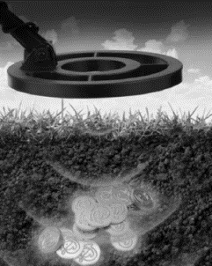
They operate on the principle of electromagnetic induction. The coil in the detector is supplied with an alternating current.
- Give a detailed explanation of how a current is induced in the metal that is being detected.

The magnitude and direction of an induced emf are determined by Faraday’s law of electromagnetic induction and Lenz’s law of electromagnetic induction.
- State Faraday’s law of electromagnetic induction.
- State Lenz’s law of electromagnetic induction.
- Describe a laboratory experiment to demonstrate either one of these laws.

A circular coil of 500 turns and radius 6.0 cm enters a magnetic field moving with a constant velocity of 8 m s^{–1} perpendicular to the field.
The resistance of the coil is 2.3 Ω and the magnetic flux density of the field is 4.5 mT.
- Calculate the time taken for the coil to fully enter the field.
- Calculate the average emf induced as the coil enters the field.
- Calculate the average current in the coil as it enters the field.

Lenz law demonstrations

2014 Question 12 (d) [Higher Level]
- State Faraday’s law of electromagnetic induction.
- Describe an experiment to demonstrate Faraday’s law.
- A hollow copper pipe and a hollow glass pipe, with identical dimensions, were arranged as shown in the diagram.
A student measured the time it took a strong magnet to fall through each cylinder.
It took much longer for the magnet to fall through the copper pipe.
Explain why.

2008 Question 8 [Higher Level]
- What is electromagnetic induction?
- State the laws of electromagnetic induction.
- A bar magnet is attached to a string and allowed to swing as shown in the diagram. A copper sheet is then placed underneath the magnet.
Explain why the amplitude of the swings decreases rapidly.
- What is the main energy conversion that takes place as the magnet slows down?

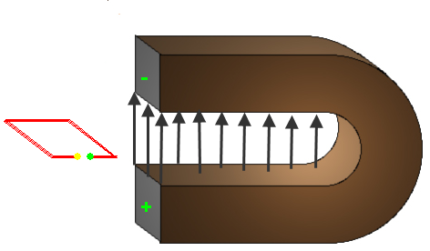
- A metal loop of wire in the shape of a square of side 5 cm enters a magnetic field of flux density 8 T.
The loop is perpendicular to the field and is travelling at a speed of 5 m s^{–1}.
How long does it take the loop to completely enter the field?
- What is the magnetic flux cutting the loop when it is completely in the magnetic field?
- What is the average emf induced in the loop as it enters the magnetic field? {this diagram wasn’t included in the question but it does help to visualise what’s going on}.

2004 Question 12 (c) [Higher Level]
- What is electromagnetic induction?
- Describe an experiment to demonstrate electromagnetic induction.
- A light aluminium ring is suspended from a long thread as shown in the diagram.
When a strong magnet is moved away from it, the ring follows the magnet.
Explain why.
- What would happen if the magnet were moved towards the ring?

2003 Question 12 (d) [Higher Level]
- State the laws of electromagnetic induction.
- A small magnet is attached to a spring as shown in the diagram.
The magnet is set oscillating up and down. Describe the current flowing in the circuit.
- If the switch at A is open, the magnet will take longer to come to rest. Explain why.

2022 Question 14 (d) [Higher level]
- State the laws of electromagnetic induction.
- A strong magnet is suspended from the end of a string and oscillates in a plane with a constant amplitude.
Describe what is observed when a sheet of copper metal is placed under the oscillating magnet.
- Explain this observation.
- Describe what would be observed if instead of the copper, a sheet of plastic was placed under the oscillating magnet.
- Explain this observation.

2021 Question 10 [Higher Level]
A current flowing through a conductor creates a magnetic field around it.
- What is a magnetic field?
- Describe an experiment to show the magnetic field around the conductor.
- Draw the shape and direction of this magnetic field.

When placed in an external magnetic field, a current-carrying conductor may experience a force.
- The magnitude of this force depends on a number of factors. Name three of them.
- Derive an expression for the force F experienced by a charge q travelling with velocity v perpendicular to a magnetic field of flux density B.

A square loop of side 5 cm enters a magnetic field of flux density 0.4 T while travelling at a velocity of 6 m s⁻¹ parallel to one side of the square. The square is perpendicular to the direction of the field.

- Use Faraday’s law of electromagnetic induction to calculate the average emf induced in the loop as it enters the field.
- The other law of electromagnetic induction is Lenz’s law. State Lenz’s law.
- Explain how Lenz’s law is a special case of the principle of conservation of energy.

Self-induction
2007 Question 12 (c) [Higher Level]
- State Faraday’s law of electromagnetic induction.
- Describe an experiment to demonstrate Faraday’s law.
- A resistor is connected in series with an ammeter and an ac power supply. A current flows in the circuit. The resistor is then replaced with a coil. The resistance of the circuit does not change.
What is the effect on the current flowing in the circuit? Justify your answer.

2002 Question 12 (c) [Higher Level]
- What is meant by electromagnetic induction?
- State Lenz’s law of electromagnetic induction.
- In an experiment, a coil was connected in series with an ammeter and an a.c. power supply as shown in the diagram.
Explain why the current was reduced when an iron core was inserted in the coil.
- Give an application of the principle shown by this experiment.

2016 Question 10 [Higher Level]
- State Faraday’s law of electromagnetic induction.
- Describe an experiment to demonstrate this law.
- Derive an expression for the effective resistance of two resistors in parallel.

A coil consists of 150 turns of wire and has a total resistance of 200 Ω. It is connected in series with a 120 V d.c. power supply and a parallel combination of a 200 Ω and a 50 Ω resistor, as shown.
- Calculate the current in the coil
- Calculate the current in the 50 Ω resistor.

The d.c. supply is then replaced with an a.c. supply.
It takes 3 ms for the magnetic flux cutting the coil to increase by 4.5 × 10^{–4} Wb.
The average voltage of the a.c. supply during this time period is 120 V.
- Calculate the average emf induced in the coil during the 3 ms time period
- Calculate the average current in the coil during this period.

2017 Question 8 {last 2 parts} [Higher Level]
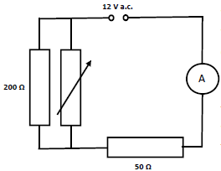

The variable resistor is then removed.
In further investigations, the 50 Ω resistor was then replaced with (a) a coil of resistance 50 Ω and (b) a diode, as shown.
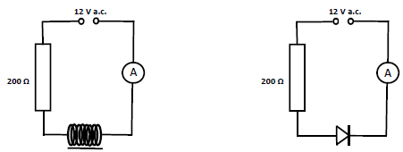
- In each of the investigations, what effect did the replacement have on the current flowing?
- Justify your answer in each case.

Transformers: ordinary level questions

2002 Question 9 [Ordinary Level]
- What is electromagnetic induction?
- Describe an experiment to demonstrate electromagnetic induction.
- The transformer is a device based on the principle of electromagnetic induction.
Name two devices that use transformers.
- Name the parts of the transformer labelled A, B and C in the diagram.
- The mains electricity supply (230 V) is connected to A, which has 400 turns. C has 100 turns.
What is the reading on the voltmeter?
- How is the part labelled B designed to make the transformer more efficient?
- The efficiency of a transformer is 90%. What does this mean?

2004 Question12 (c) [Ordinary Level]
- A transformer is a device based on the principle of electromagnetic induction.
- What is electromagnetic induction?
- Name another device that is based on electromagnetic induction.
- Name the parts of the transformer labelled A, B and C in the diagram.
- Part A has 400 turns of wire and part B has 1200 turns. Part A is connected to a 230 V a.c. supply. What is the voltage across part B?

2007 Question 12 (d) [Ordinary Level]
The diagram shows a transformer.
- What is electromagnetic induction?
- Name the parts labelled A and B.
- The input voltage is 230 V. Part B has 4600 turns and part C has 120 turns. Calculate the output voltage.
- Name a device that uses a transformer.

2011 Question 9 (b) [Ordinary Level]
Transformers are used to step up or step down a.c. voltages.
- What is meant by a.c.?
- Draw a labelled diagram showing the structure of a transformer.
- The input coil of a transformer has 200 turns of wire and is connected to a 230 V a.c. supply.
What is the voltage across the output coil, when it has 600 turns?

2013 Question 11 [Ordinary Level]
- Why are high voltages used to transmit power over the national grid?
- Why is the power supplied to domestic customers at lower voltages?
- Name two renewable and two non-renewable energy sources used to generate electricity.
- The national grid uses alternating current (a.c.) rather than direct current (d.c.).
What is the difference between them?
- Name the device used to convert high voltages to lower voltages.
- Give the principle of operation of the device named in part (vi).
- Name the unit of electrical energy that is used in the delivery of electricity to homes and businesses.

Transformers: higher level questions

2013 Question 8 (a) [Higher Level]
- The diagram shows a circuit used in a charger for a mobile phone.
Name the parts labelled F, G and H.
- Describe the function of G in this circuit.
- Sketch graphs to show how voltage varies with time for
the input voltage and the output voltage, V_{XY}.
- The photograph shows the device H used in the circuit.
Use the data printed on the device to calculate the maximum energy that it can store.

2015 Question 11 [Higher Level]
Read the following passage and answer the accompanying questions.
In the years since his death, Nikola Tesla (1856–1943) has enjoyed a curious legacy. On the one hand he is acknowledged for his contributions to alternating current and in 1960 “tesla” was adopted as the name of the unit of measure for magnetic flux density. On the other hand, thanks to the many colourful predictions he made about his inventions, Tesla has become a figure in popular culture.
Tesla was the champion of distributing electric power using alternating current rather than direct current. The problem with using direct current for electric lighting is that there is no easy way to transfer power from one d.c. circuit to another. Because the generator and the light bulbs must then be part of the same circuit, safety requires that the entire circuit uses low voltage and large current. Alternating current makes it easy to transfer power from one circuit to another, by electromagnetic induction in a device called a transformer.
The wires that carry the current a long distance are part of a high voltage, low current circuit and therefore waste little power.
As well as his work with alternating current, Tesla did pioneering work on the transmission of radio-waves and X-rays. In 1898 he demonstrated a radio-controlled boat.
The car manufacturing company, Tesla Motors, is also named in honour of Tesla. The Tesla Roadster uses an a.c. motor descended directly from Tesla’s original 1882 design.
It is the first production car to use lithium-ion cells and has a range of greater than 300 km.
(Adapted from Tesla: Inventor of the Electrical Age, W Bernard Carlson, Princeton University Press, 2013)

(a) Define the tesla.
(b) Sketch voltage-time graphs for (i) an a.c. supply and (ii) a d.c. supply.
(c) Explain the term electromagnetic induction.
(d) Why does a transformer not work with direct current?
(e) Why is it inefficient to use low voltage when transmitting electricity?
(f) The peak voltage of an a.c. supply is 321 V. Calculate the rms voltage.
(g) Explain why it is necessary to use rms values when comparing a.c. and d.c. electricity.
(h) Give one advantage and one disadvantage of electric cars.

2022 Deferred Question 9 [Higher Level]
- State Faraday’s law of electromagnetic induction.
- State Lenz’s law. of electromagnetic induction.
- Describe how you would demonstrate each of these laws in the laboratory.

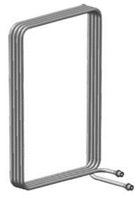
- The diagram shows a square coil of wire of side 20 cm. There are 4 turns of wire in the coil.
The coil is placed perpendicular to a magnetic field of flux density 1.5 × 10^{–3} T.
Calculate the magnetic flux through the coil.

- The coil is then moved out of the magnetic field in a direction parallel to one of the sides of the square.
If the speed at which the coil is moved is 2.5 m s^{–1}, calculate the emf induced in the coil.

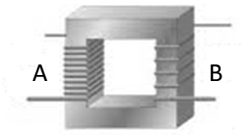
The diagram shows a transformer. The coils A and B are wound on a laminated iron core.
- What happens in coil B when an alternating voltage is applied to coil A?
- What is the purpose of a transformer?
- Describe the principle of operation of a transformer.

Einstein said that playing with magnets was his first clue that there was “something behind things, something deeply hidden,” This “action at a distance” was also what deeply unsettled Newton when thinking about gravity.
Bird Migration Many migratory birds such as swallows have a mineral in their brains known as magnetite, which helps them navigate as they travel across the oceans. We also now know that sharks are sensitive to magnetic fields. Scientists put a number of hammerhead sharks into a pool which they surrounded with copper wire. When they turned on the current through the wire there was a noticeable change in behaviour of the sharks.
The Earth’s magnetic field appears to be the result of electric currents circulating in the molten outer part of the iron-rich core of the planet, which is at a temperature of at least 2200 °C. It is as though there is a bar magnet in the centre of the Earth, with its south end beside our geographic North Pole. This is why the north pole of our magnets point there (a little confusing, innit?). However the magnetic North Pole is not directly in line with the geographic North Pole (it would be quite a coincidence if it was) difference is known as magnetic variation, and once the angle is known, the Earth’s magnetic field can be used for accurate navigation. But this arrangement is not immutable over geologic timescales. Every 500,000 years or so the system “flips”, and the magnetic field undergoes complete reversal; the north magnetic pole becomes the south and vice versa. The last time this happened was about three quarters of a million years ago, so one might infer that a flip is overdue. Some scientists, indeed, have been bold enough to predict that it will occur suddenly somewhere around 2,000 years from now. It’s much more likely however that the flip, whenever it may come, while ‘sudden’ on a geologic timescale, would actually be much more gradual, taking perhaps 1,000 years or more. This view is supported by the fact that no major species extinctions have been associated with the last magnetic field reversal 750,000 years ago. So how do scientists know that magnetic field reversals have occurred in the past? Most of the evidence lies on the ocean floor. As some continental plates sink below the surface, new material emerges from under the sea-bed and as it reaches the surface it spreads our like a freshly laid carpet. This occurs very slowly. As the magnetic field of the Earth changes, it gets recorded in the way iron orientates itself with the material. So simply going over the ‘carpet’ with a magnetic compass results in the compass switching direction at regular intervals. Knowing how quickly the material spreads leads to a determination of the time intervals between magnetic flips. What would happen if the molten iron inside the Earth were to cease to slosh around completely? For starters there would be no magnetic field. And the consequences of this? Without the protection of the magnetic field life on Earth, including life for all human beings, would be greatly subject to greatly enhanced and very harmful cosmic radiation; satellites would be nudged from orbit; the climatic consequences could well be dramatic.
Because the conductor contains gazillions of electrons and what they don’t tell you in textbooks is that each electron is like a very small magnet. Normally these electrons have random orientations so their magnetic fields all cancel out. But if you pass a current through the conductor the electrons all ‘line up’ the same way, as do their magnetic fields, so the strip of metal now acts as a magnet. Put an external magnet beside this conductor and the conductor will either be attracted to it or repelled by it. This is a little simplistic but it’s better than no explanation at all, which is what you get everywhere else. A more detailed and accurate explanation involves Einstein’s theory of special relativity. See thephysicsteacher for a related video from Veritasium.
I’m not sure that it’s possible to overstate the importance of this discovery. Michael Farday (for it was he who discovered this link – it was also the world’s first electric motor) certainly seemed to appreciate the significance of this. This is how he reacted at the time: “All at once he exclaimed, ‘Do you see, do you see, do you see, George?’ as the wire began to revolve . . . I shall never forget the enthusiasm expressed in his face and the sparkling in his eyes!”
The moving coil loudspeaker The back of the speaker contains a coil of wire wrapped around a magnet. This system is connected to a paper cone which can move over and back. When an electric current flows through the coil it causes the coil of wire to experience a force so it will in or out depending on the direction of the current. The current in this case is alternating which means it changes direction. The end result is that the sound wave produced will have the same frequency as the electrical signal and therefore will seem identical to the sound which generated the current.
I have to admit that magnetic flux density is a pretty strange term for the strength of a magnetic field. Turns out that there is a little more to it than this and we will re-visit it in the next chapter when all will become clear. At least one part of that sentence is true.
The tesla Check out Tesla on the YouTube – he’s a cult figure straight out of The X-Files. Inventions: A telephone repeater, rotating magnetic field principle, polyphase alternating-current system, induction motor, alternating-current power transmission, Tesla coil transformer, wireless communication, radio, fluorescent lights, and more than 700 other patents. By the way, can you remember where we came across this guy before? Hint: He was a big into resonance. Bigger hint: Mechanical hammer and a wall.
This is used to determine the direction of the force, and hence the direction in which the conductor will move. So the assumption is that you will know the direction of the current (positive to negative) and the direction of the magnetic field (north to south). You then use the configuration in the diagram to figure out the direction of the force. This is so much fun to teach. Unfortunately it has never been asked in over 20 years of exams so I am not regrettably coming to the conclusion that it never will be
Ampere In his early years, Ampere saw the sway of the reign of terror following the French Revolution. He witnessed as a boy the murder of his father in 1789 when every titled person was subject to execution or imprisonment. Trauma of this tragedy, followed by his wife's death in 1803, made him an embittered person, spending his time as an introvert. Perhaps, it was this introversion that spurred him to pursue electricity and magnetism where his contributions earned him an immortal place in history of science, and a name that is synonymous with what is quite possibly the nastiest definition on the Leaving Cert Physics syllabus. And if that’s not bad enough, in 2019 a new definition was adopted which defined the ampere in terms of the transfer of the elementary charge, e. So the definition above is not even valid any more, but for the benefit of just this section we’re going to assume that we’re all living pre 2019 – which also means that we can pretend that 2020 will finally be Mayo’s year. I would be astonished if this definition was actually asked given that it’s no longer valid, but until we’re told officially that it won’t get asked it’s best to include it.
I numbered the different parts so that they might act as a checklist to help you remember what is without doubt the nastiest definition of the whole course. I’m just glad that it’s you that has to learn it and not me. Back to Tesla This is Tesla talking about the modern smartphone… in 1926: “When wireless is perfectly applied the whole earth will be converted into a huge brain, which in fact it is, all things being particles of a real and rhythmic whole. We shall be able to communicate with one another instantly, irrespective of distance. Not only this, but through television and telephony we shall see and hear one another as perfectly as though we were face to face, despite intervening distances of thousands of miles; and the instruments through which we shall be able to do his will be amazingly simple compared with our present telephone. A man will be able to carry one in his vest pocket.”
The exact relationship between the speed of the magnet relative to the coil and the size of the emf induced in the coil was investigated further and the result is now known as Faraday’s law of electromagnetic induction.
Named after Professor Weber – he was a professor who lectured Albert Einstein. Einstein held him in contempt because Weber refused to give any time to recent developments in Physics, developments which contradicted – or at the very least questioned – the traditional teachings. Einstein refused to address Weber by his proper title Herr Professor Weber, instead he addressed him as Herr Weber. Weber in turn refused to write a reference for Einstein (mind you the fact that Einstein couldn’t be bothered going to Weber’s lectures probably didn’t help). End result? Einstein could only get a job as a lowly clerk in a patent office. This did have the advantage of providing Einstein with a lot of free time to think, time which he appears to have put to good use.
We already introduced the concept of magnetic flux density (B) in the last chapter but didn’t explain it. We can consider the magnetic flux density as any of the following: - the number of magnetic field lines per unit area or - the number of magnetic field lines per square metre or - the density of the magnetic flux or - the magnetic flux density (which is what we actually call it)
So it’s like B (magnetic flux density) represents the number of lines per square metre and A represents the number of square metres so B ×A corresponds to the total number of magnetic field lines passing through area A.
In this case the proportional constant turns out to be 1. Remember where we came across this before? hint: F = ma The minus sign is a reference to Lenz’s Law which we’ll come back to in the next section but can be ignored for maths questions. We are just looking for the magnitude (the number) of the induced emf so it doesn’t matter if we use (final flux – initial flux) or (initial flux – final flux). I go with whichever version will give me a positive answer but even if we get a negative answer we just ignore the negative sign. Lenz’s law is a consequence of the conservation of energy – if the induced magnetic field attracted the magnet, then the magnet would move faster, resulting in a greater induced emf and magnetic field, resulting in the magnet moving even faster and there would be more energy afterwards than there was beforehand which is obviously not possible.
Why historically do we in Europe use electricity at 240V 50Hz, whereas US for example uses 110V? It seems to be a trade-off issue; 220 V is more likely to electrocute, but the lower current means that fewer people die from fires caused by overheated cables. Alternatively it may be related to cost; lower current means that copper cabling don’t need to be as thick as they would for higher current. Note that all building sites must use 110 volts, that’s why you see those yellow boxes (transformers) attached to all heavy-duty equipment. However they should also be using heavy-duty cable (i.e. large diameter) to absorb the extra heat given off.
When the diaphragm at one end of the microphone detects a sound wave it causes the diaphragm to vibrate. The diaphragm is attached to a coil of wire wrapped around a magnet; as the coil moves over and back across the magnet it causes an emf to be induced in the coil. This in turn will cause an alternating current to flow in the coil and this will have the same frequency as the original sound wave. This microphone can then be connected to an amplifier and speaker.
“Trust you will avoid the gigantic mistake of alternating current”. Lord Kelvin (1824-1907) Tesla (remember him) had invented a way to generate electricity in the form of alternating current but his great rival at the time was Edison (inventor of the lightbulb) who favoured direct current. Edison roped in Kelvin to back him (Kelvin was recognised as the greatest living scientist at the time), but even with the backing of Kelvin he still lost out because Tesla’s alternating current is more practical (easier to increase and decrease with transformers). Check out any of the numerous documentaries on Tesla on YouTube. He also plays a significant role in The Prestige which isn’t bad.
We have a problem. If the current (or voltage) is constantly changing, how can we say what its value is? We can’t take the average value because it’s zero. We could take the height of the wave – but this keeps changing with time. We could take the maximum height – but if the maximum height is say 3 amps, it still won’t have the same heating effect as a direct current of 3 amps (the diagram should help you to see why). To solve the problem, we use a little mathematical trickery: We use what’s known as the root mean square value (V_{rms.}). This is obtained by dividing the maximum value (V_{max} ) by √2.
The soft iron core (it’s also laminated) helps to confine the magnetic flux such that more of it reaches the secondary coil rather than being lost to the external space. I’ve no idea how this works; I think of it as being like total internal reflection but don’t tell anyone that I said that.
Define self-induction Student answer: If you have no friends so can’t join any clubs so have to invent your own club, self-induction is the process of inducting yourself into this club. Touch of class from Sean Harper

